**National University of Computer & Emerging Sciences, Karachi  
Spring-2022 School of Computing (BSSE)  
Lab - Final Examination, Spring 2022 (Paper A)  
2nd June, 2022, 08:30 am – 10:30 am** Fast

|  |  |  |
| --- | --- | --- |
| **Course Code:** CL1004 | **Course Name:** Object Oriented Programming Lab | |
| **Instructors:** Mr. Zain Ul Hassan, Ms. Abeer Gauher | | |
| **Student Roll No:** | | **Section:** |

**Instructions:**

READ carefully the following instructions before attempting the paper.

* Except your Roll No and Section, **DO NOT WRITE** anything on this paper.
* The Final Exam consists of **3 questions on 2 pages**. Make sure that you have all of these and that they are all legible.
* Read all questions and their instructions thoroughly before you begin. It is always worth your time to plan ahead!
* In case of any ambiguity, you may make assumptions but your assumption must not contradict any statement in the question paper.
* **DON’T** share your program, if your code is matched to any member of your class, both will get **straight F** in the course without asking who shared or who magically copied.

**Submission guidelines:**

* Submit the java file named as 211234_Q1.java, k211234_Q2.java for every question and submit them on Google Classroom.

**Time Allowed**: 120 minutes **Maximum Marks**: 50

**Question 01 [marks: 15] [Estimated Time: 30 minutes]**

Stack is a data structure that have 3 major operations. it operates using a variable called top. Initially, the top variable is -1. whenever an entry is added to a stack, the top increments by 1 and whenever we delete an entry, it decrements. follow figure for better understanding. Now, create a generic class name as MyStack that contains:

* a private generic arraylist/array
* a public integer variable top to control the indices of arraylist
* a parameterized constructor
* accessors & mutators wherever needed
* generic functions for push, pop and isEmpty

where, push will insert an element to stack and update the top, pop will remove an element present at the top and decrease top variable and isEmpty will check whether the Stack is empty or not

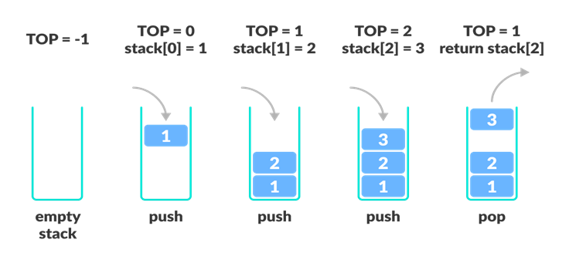

Create main methods that will push 3 elements to stack and pop only two elements after that it’ll check whether the stack is empty or not.

**Question 02**   **[marks: 15]** [**Estimated Time: 30 minutes]**

Nadra wants to maintain a record of all the covid vaccinated personnel. For that they created a file named Vaccination Log. Whenever a person visits a vaccination center, a list of vaccines is displayed as follows:

* Sinovac
* Sinopharm
* Pfizer
* CanSino

after this list, the portal asks the user to enter the name of person who wants to get vaccinated and vaccination name that he/she wants.

create a class that store the vaccinated person name along with the vaccination name. whenever a person enters a record, the file is written as:

**<vaccinated person's name> got <vaccine name> Vaccine**

After adding 4 to 5 records, Display the contents of vaccination log file

***Question 03* [marks: 20] [Estimated Time: 30 minutes]**

A university wants to make some changes to their existing system. Your services are required as a Java developer to make the required changes for the university. Implement the scenario given in the figure.

**Person**

**Employee**

Print( )

Salary( )

Faculty

1. The class Faculty has the attributes name, email address, department. All are private members. Accessors and mutators are required for all the attributes.
2. Make a parameterized constructor that sets all the attributes.
3. Each lecture taken by a faculty is Rs. 1000 per credit hour. If a faculty member takes more than 9 credit hours and less than or equal to 12, each credit hour above 9 is Rs.1500. Calculate the monthly salary of the faculty by using the salary( ) method. Credit hours should not be less than 0 and greater than 12, otherwise display “Please enter value above 0 and less than or equal to 12") and do not allow the user to proceed until the condition is satisfied.
4. Create a function courseinfo( ).Each faculty member is required to teach at least 2 courses. Add an array list that maintains a record of the courses taught by a faculty member in a current semester and display those courses. If any faculty member teaches less than 2 courses display “You need to teach at least 2 courses in a semester” and do not allow the user to proceed until the condition is satisfied.
5. Implement the print () method to print all the details of a faculty member.
6. Demonstrate all the functionality in the main program.

***Best of Luck ☺***